Step 3_Post-learning (20 min)
■Basic Data
Title | Reflecting on Our Response to the Earthquake Early Warning (EEW)
Goal | 1.Reflect on one’s own behavior and actions during the response drill.  2.Reaffirm appropriate actions to take when hearing an EEW.  3.Understand the importance of protecting oneself during an earthquake.
Grade | Grade 5 - 6 (Applicable to lower graders by adjusting words in Note)
Subject | Integrated class / Extra-curricular Activity for post-learning of the drill in case of EEW
Style | Individual (worksheet) → Whole Class (sharing) : 20-minute
Material | Worksheet(Step 3_Post-Drill), Leaflet for EEW  ※Downloadable in Utsunomiya Local Meteorological Office

■Procedure
Timeline | Content | 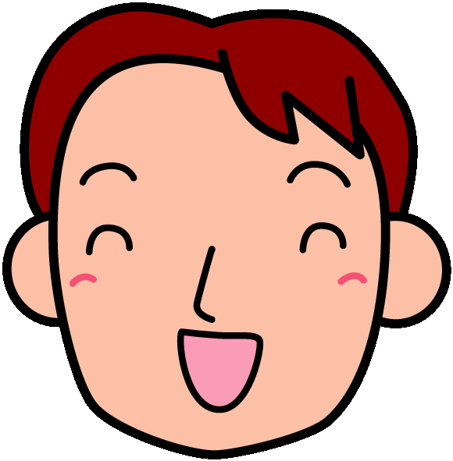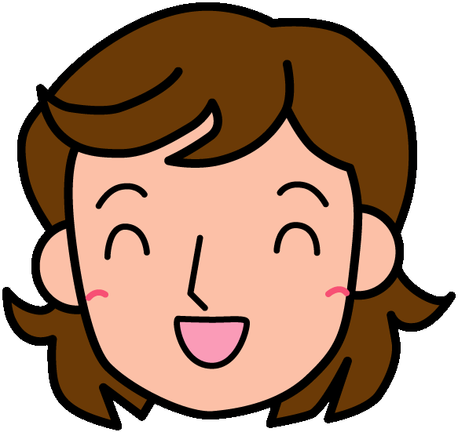Note
- Introduction & Activity 1 (1 min) | - To reflect own response in Drill | Let’s review whether you could take an initiative to protect yourself in the drill with Earthquake Early Warming.  ※Hand Worksheet (Step 3_Post-Drill).
- Activity 2  (17 min) | 2. To reflect the proper response in EEW  1-1. Worksheet_1 (3 min)  1-2. Worksheet_2-3 (5 min)  1-3. Sharing (7 min)  1-4. Consolidation (2 min) | Please answer No.1 with four questions.  ※Low graders can answer one by one and choose the applicable options together.  Please answer No.2 -3: 2) where you were, and 3) how you protected yourself and why you did so.  Let’s share your answers.  ※Write the answers on the blackboard.  ※Let pupils use colored pencils for others’ opinions.  ※Answer each pupil’s question, but do not let them talk to each other.  Let’s review the important things to protect yourself in earthquakes. Think individually where risky places and what are risky in case of EEW or earthquakes. Safe places are 1) nothing drops, 2) nothing falls, and 3) nothing trips. It is important to evacuate to a safer place.  ※Review how things move in earthquakes.  Another importance is to stay calm, think and act initially wherever you are. Your teachers and adults are not always with you.  ※Let them remind the importance of own thought and action.  What would you do you see younger children and senior people around you in case of EEW? You can say, “We will have and earthquake. Protect yourself.” Same as in places where many people gather.  ※Encourage higher graders warn lower graders.  ※Let them know the tendency of taking time to start action in groups.
- Consolidation (2 min) | - To learn the importance to protect oneself in earthquakes (2 min) | We had the drill at school, but we can’t know when earthquakes happen. There are lots of earthquakes in Japan. They happen anywhere and anytime like on the way from home to school, at home while parents out, at cram schools, in shopping with family, and on cars or trains.  This drill is to protect yourself in case of EEW or earthquakes.  Remind what you learn in mind and protect yourself even outside of school in case of EEW or earthquakes.  ※Remind the importance of protecting themselves outside of school  Please teach what you have learned today to your family and talk with the member of what you should respond in case of EEW or earthquakes.  ※Aim to enlighten guardians by the talk

■Evaluation
- Reflect what own response was in the drill by Worksheet
- Know proper responses in earthquakes through pre- to post-drill.

■Remarks
・This program is based on the reflection of the drill with EEW, not on the national course of study.
・K5-6 can connect EEW mechanism to science learning.
Utsunomiya Local Meteorological Office

